**Project Report**

**INTRODUCTION**

**1.1-Overview** Starting a new company can be an exciting and rewarding experience, but it also requires careful planning and analysis to ensure that the business is viable and successful. There are several key areas that you should focus on when conducting a startup company analysis. Conducting a thorough analysis of these areas can help you identify potential challenges and opportunities, and develop strategies to address them. It is also important to regularly review and update your analysis as the business progresses, in order to adapt to changing market conditions.

**1.2-Purpose** Starting a new company can be an exciting and rewarding experience, but it also requires careful planning and analysis to ensure that the business is viable and successful. There are several key areas that you should focus on when conducting a startup company analysis. Conducting a thorough analysis of these areas can help you identify potential challenges and opportunities, and develop strategies to address them. It is also important to regularly review and update your analysis as the business progresses, in order to adapt to changing market conditions

**Problem Definition & Design Thinking**

**2.1 Empathy Map**

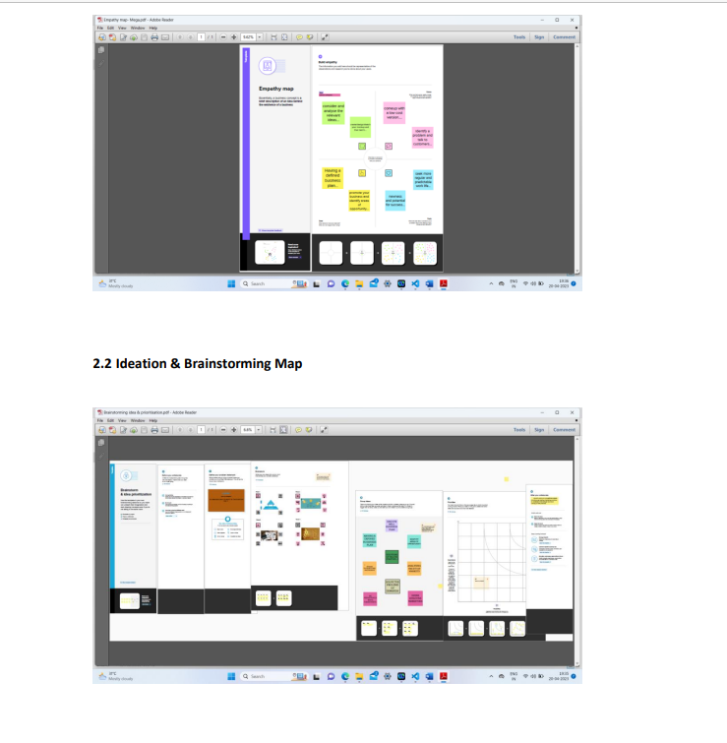

Result

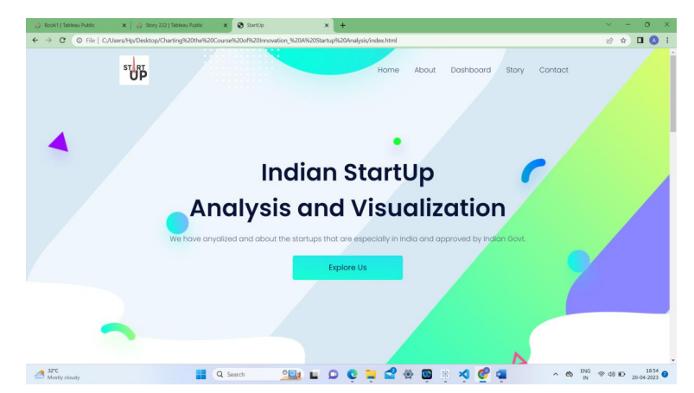

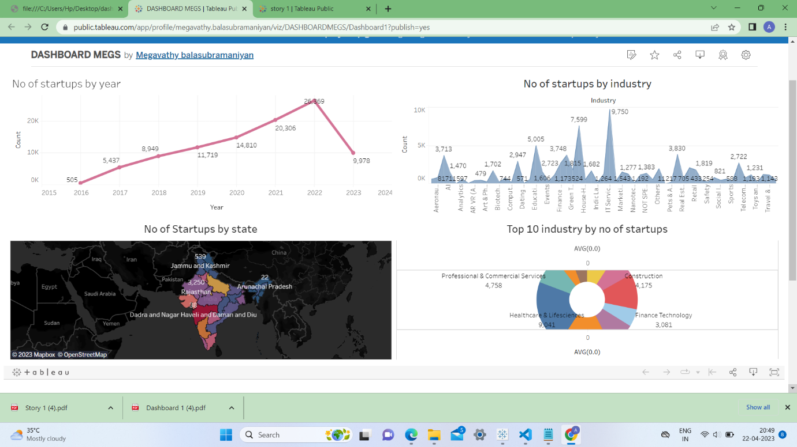

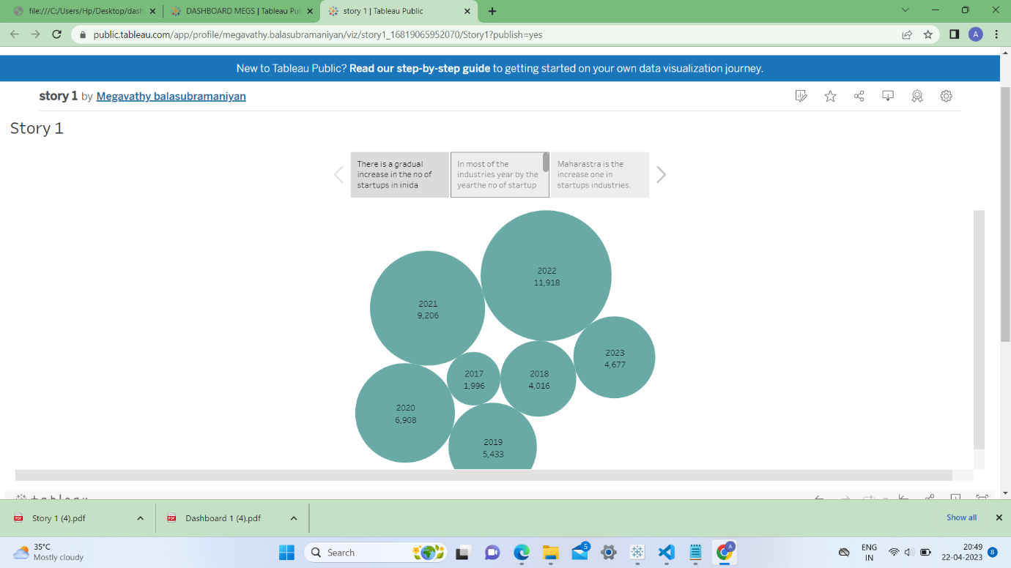

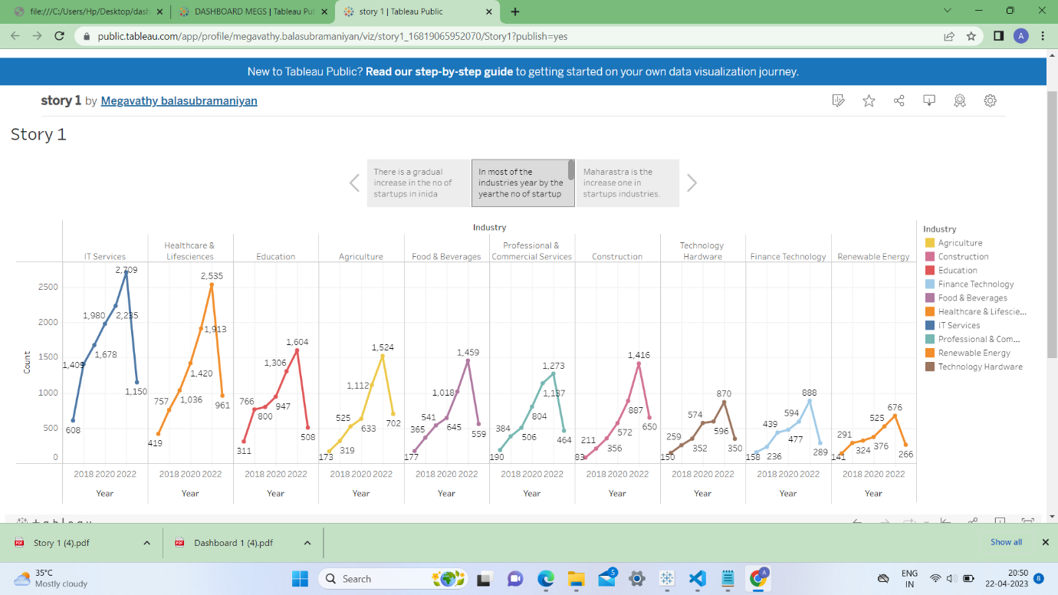

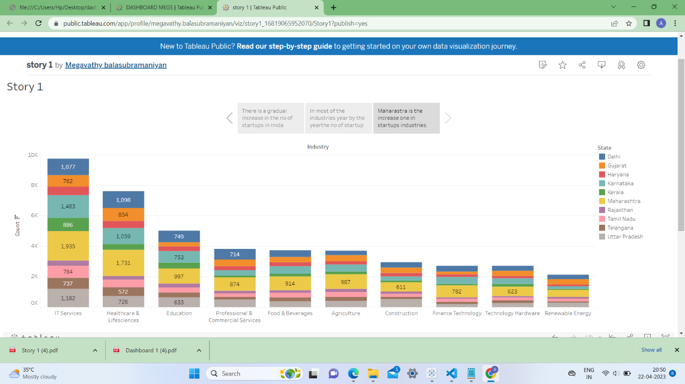

**ADVANTAGES**

1)New age working style

2)Best place to explore our potential

3)Attractive Benefits

4)Flexible working hours

5)Better utilization of resources.

**DISADVANTAGES**

1)There’s always plenty of work

2)Risk of failure

3)Funding problem

4)Inexperienced can be a big trouble

5)low income

**APPLICATIONS**

1)Consider and analyse the relevant markets

2)Note down your ideas and expand them

3)Carry out competitive analysis

4)Execute a market survey.

**CONCLUSION**

The advantages and disadvantages of startup businesses, you need to compile your team. The next 5-10 years recruit at least a couple of experienced employees ,and gain more experience before putting your head into the business.

**FUTURE SCOPE**

Startsups in india are expected to raise USD180 billion in 2023

**APPENDIX**

1. Source Code
2. Attach the code for the solution built